**Angular Course Content**

The course is focussed on understanding the basics and advanced concepts of Angular 9. We will be having a short introduction on Reactive Programming and concepts of Rxjs. Trainees are expected to have a bit of understanding of JavaScript and Frontend JavaScript Execution.

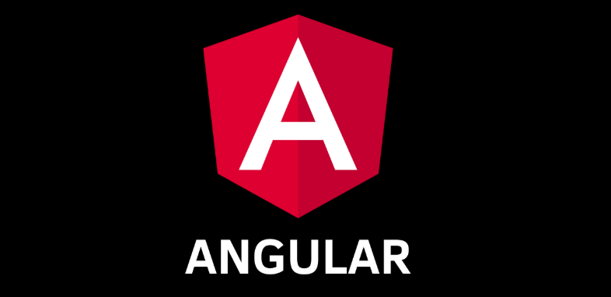

1. **Working with ES6 Features** 
   1. Working with Arrow Functions
   2. Working with “let” and “const”
   3. Understanding Spread and Rest Operators
   4. Understanding the “yield” keyword
   5. Working with Generators
   6. Working with ES6 Export and Imports
   7. Working with Classes in JavaScript
2. **Working with TypeScript** 
   1. Understanding JavaScript Object-Oriented Architecture
   2. Working with TypeScript Classes
   3. Inheritance in TypeScript
   4. Working with Generics
   5. Understanding TypeScript Interfaces
   6. TypeScript to JavaScript Equivalent
3. **Getting Started with Angular** 
   1. Setting the Environment
   2. Setting up an Angular Application
   3. Installing an Angular Application
   4. Running an Angular Application
4. **Introduction to Components (1 Hour)**
   1. What Is a Component?
   2. Creating the Component Class
   3. Defining the Metadata with a Decorator
5. **Templates, Interpolation, and Directives** 
   1. Building a Template
   2. Using a Component as a Directive
   3. Binding with Interpolation
   4. Adding Logic with Directives: ngIf
   5. Adding Logic with Directives: ngFor
6. **Data Binding & Pipes** 
   1. Property Binding
   2. Handling Events with Event Binding
   3. Handling Input with Two-way Binding
   4. Transforming Data with Pipes
7. **Components, Interfaces, and Lifecycle Hooks** 
   1. Defining Interfaces
   2. Encapsulating Component Styles
   3. Using Lifecycle Hooks
   4. Building Custom Pipes
   5. Filtering a List of Data
8. **Working with Nested Components** 
   1. Building a Nested Component
   2. Using a Nested Component
   3. Passing Data to a Nested Component Using **@Input**
   4. Passing Data from a Component Using **@Output**
9. **Services and Dependency Injection** 
   1. Building a Service
   2. Registering the Service
   3. Injecting the Service
10. **Retrieving Data Using HTTP** 
    1. Observables and Reactive Extensions
    2. Sending an HTTP Request
    3. Exception Handling
    4. Subscribing to an Observable
11. **Working With Single Page Application** 
    1. Understanding Client-Server Architecture
    2. Advantages of Single Page Application
    3. Disadvantages of Single Page Application
    4. Understanding Use Cases for Single Page Applications
12. **Navigation and Routing Basics** 
    1. How Routing Works
    2. Configuring Routes
    3. Tying Routes to Actions
    4. Passing Parameters to a Route
    5. Activating a Route with Code
    6. Protecting Routes with Guards
    7. CanLoad Guard
13. **Working with Forms**
    1. Creating Forms
    2. Two Way binding Angular Components
    3. Validating Angular Forms
    4. Working with Reactive Forms
    5. Validation in Reactive Forms
14. **Building and Deploying with the CLI** 
    1. Angular CLI Overview
    2. Working with Angular Build
    3. Deploying build to Apache Servers